Deliverables

Andrew Han and Dylan Cauwels

# 2. Circuit Diagram

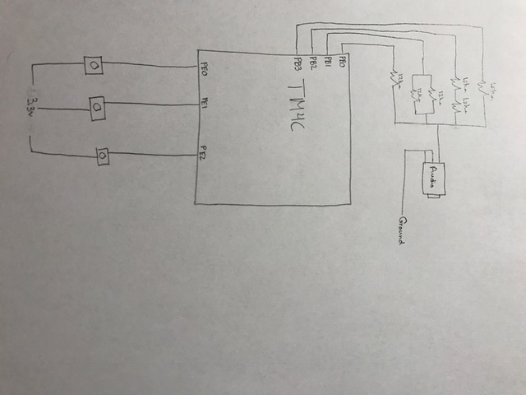

# 3. Software Design

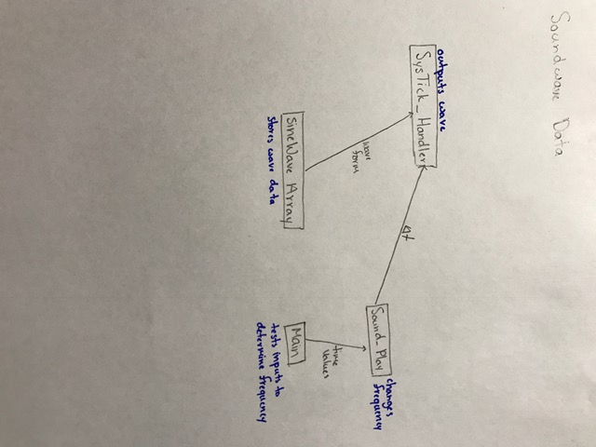

# 4. Dual Scope Screenshot]

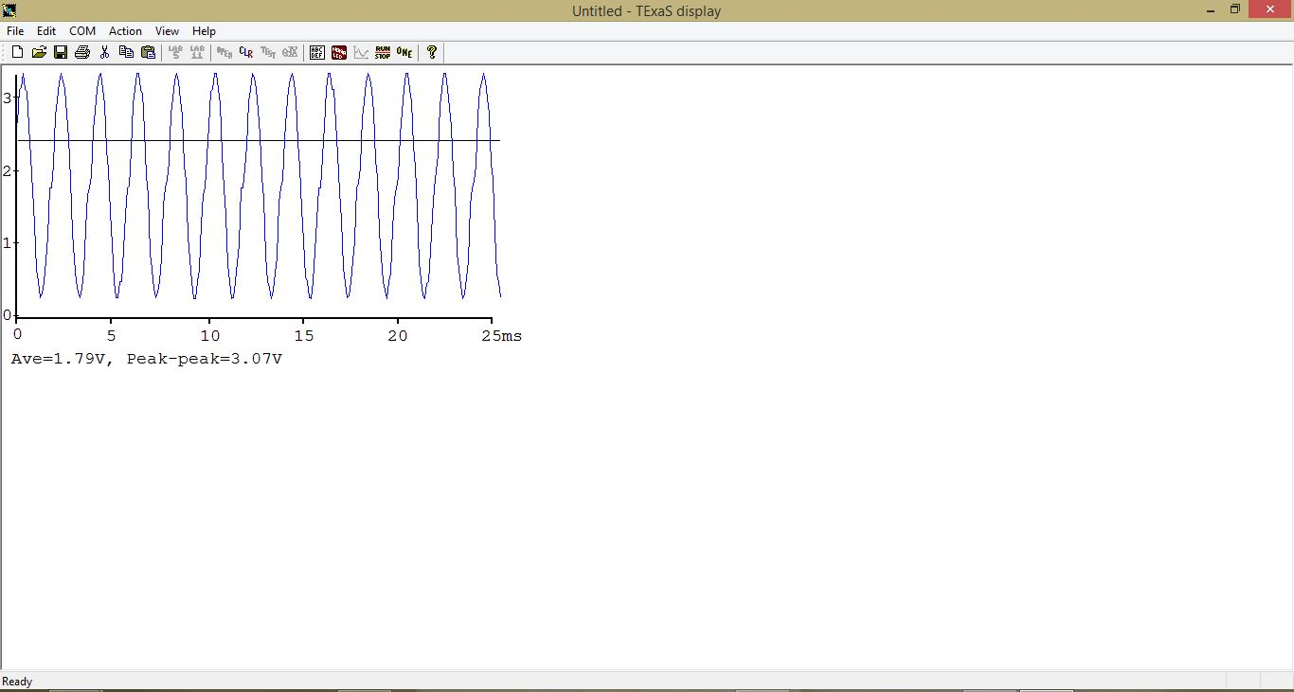

# 5. Voltage Chart

|  |  |  |
| --- | --- | --- |
| Bit3 bit2 bit1 bit0 | Theoretical DAC voltage | Measured DAC voltage |
| 0 | 0 | 0 |
| 1 | .22 | .20 |
| 2 | .44 | .43 |
| 3 | .66 | .67 |
| 4 | .88 | .90 |
| 5 | 1.1 | 1.0 |
| 6 | 1.32 | 1.31 |
| 7 | 1.54 | 1.57 |
| 8 | 1.76 | 1.77 |
| 9 | 1.98 | 2.00 |
| 10 | 2.2 | 2.18 |
| 11 | 2.42 | 2.40 |
| 12 | 2.64 | 2.66 |
| 13 | 2.86 | 2.86 |
| 14 | 3.08 | 3.07 |
| 15 | 3.3 | 3.28 |

Resolution:

Formula = 3.3/(2n – 1)

Answer: .22

Range: 0 – 3.28

Precision:

Formula: 2n

Answer: 16

# 6. Questions

a. Whenever SysTick Timer reaches 0

b. startup.s

c. Current Instruction finished, registers saved (R0 – R3, R12, Pc, LR, PSR), LR set to 0xFFFF FFF9,

IPSR set to current interrupt being processed, PC loaded with ISR address

d. signals program to pop values off stack and reload the PC, restarting the program where it left off